Heavy Vehicle Road Reform
Changes to heavy vehicle road delivery

Background paper

July 2018

Purpose of this paper
This paper provides background on reforms that the Commonwealth, State and Territory governments in Australia are pursuing to change the way that heavy vehicle road services are delivered. It seeks to explain what we are doing and why we are doing it, including an outline of what a reformed system might look like.
It is intended that this background paper supplement other papers and proposals which are the subject of public consultation, by explaining how different elements of the proposed reforms fit within the bigger picture.

Table of contents
1. Introduction: The need to act 3
2. Heavy vehicle investment and charging: The starting point for reform 4
Our current system 5
The response: Heavy Vehicle Road Reform 6
Principles of Heavy Vehicle Road Reform 6
Elements needed to realise Heavy Vehicle Road Reform 7
3. What could a new system look like? 7
4. Heavy vehicle road reform: Road map and progress to date 8
The HVRR road map 8
Progress on reform to date 9
Independent price regulation and a forward-looking cost base 10
National Heavy Vehicle Charging Pilot 10
5. Next steps 11

- Introduction: The need to act
Road infrastructure in Australia is at a historic tipping point. Demand for significant new and upgraded infrastructure is growing, including from the road transport industry which operates heavy vehicles. But it is getting harder for governments to fund the expectations and demands of road users almost entirely from general taxation revenue. In particular, road network and heavy vehicle industry productivity has plateaued or in some cases fallen due to a disconnect between road charging and funding. Increasingly, road providers have neither the funds nor incentives to expand road access (including for heavy vehicles).
To date, roads have not been the subject of a microeconomic reform process of the kind that has transformed other public infrastructure sectors such as water and electricity into customer focused utility markets.
Roads are provided as a public good, largely funded from consolidated revenues through government Budget processes with poor links between the supply of, and demand for road infrastructure. The public good model of road provision served Australia well for many years, resulting in Australia building and maintaining one of the longest road networks of any country. However, structural Budget pressures, ageing road infrastructure, the diminishing returns from fuel-based taxes and a growing passenger and freight task, mean the model for funding and using roads is unlikely to be sustainable. Technology also represents a source of disruption for the road transport sector. The uptake of alternative fuel vehicles are likely to impact the sustainability of the current road revenue model.
The road transport industry is critically important to Australia’s economy and competitiveness, and the road freight task continues to grow.
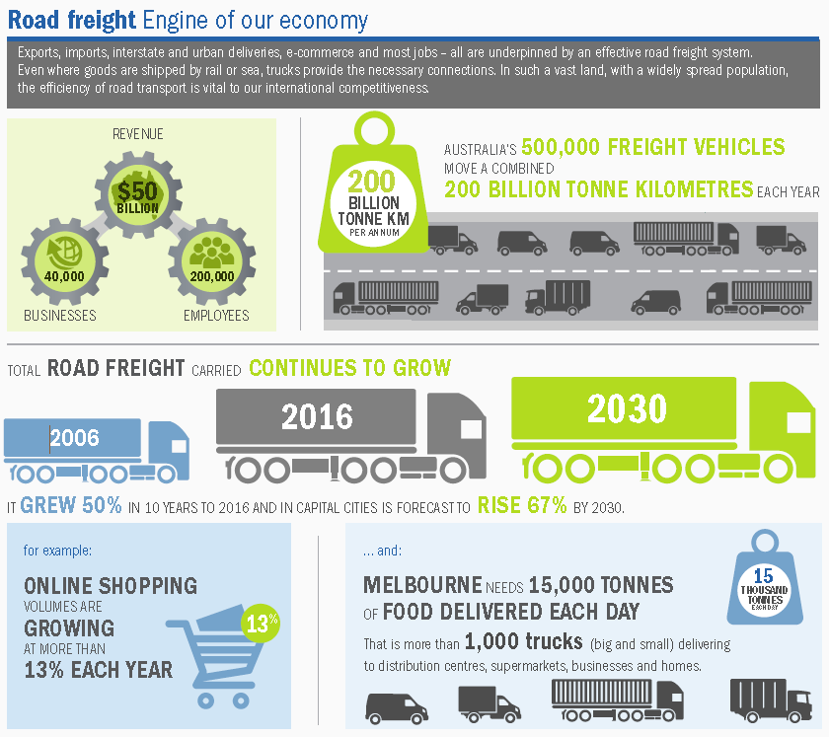
In 1995-96, 107.4 billion tonne kilometres (BTK) of freight was transported over Australian roads, while in 2015-16 the figure was almost double at 213.9 BTK.
There has been recent improvement to investment decision making (e.g. cost benchmarking, business cases and a rolling project pipeline), and infrastructure advisory bodies have been established in a number of jurisdictions. However, there is room for further improvement, to maximise efficient investments based on the needs of road users. There is also a need to promote efficient use by ensuring users value the true cost of building and maintaining road infrastructure.
While there is a need to improve the efficient provision and use of road services, there will continue to be a role for all governments to support the provision of basic road services to ensure social mobility, economic welfare, road safety and public security. Any reforms to road investment and charging arrangements must be mindful of how best to integrate roads as an economic service with roads as a community service obligation. This is especially important on roads where the true costs of road service provision would be divided among a very small number of users resulting in road charges that are considered to be too high – as would likely be the case on many rural and remote roads.
- Heavy vehicle investment and charging: a logical area for reform
There have been a number of recent reviews into Australia’s national productivity which have highlighted the need for road market reform, including for heavy vehicles:
- The Productivity Commission (PC) Five Year Productivity Review (2017);
- Infrastructure Australia Australian Infrastructure Plan (2016);
- The Competition Policy (Harper) Review (2015).
The 2007 Productivity Commission Inquiry into Road and Rail Freight Infrastructure Pricing identified that heavy vehicles are the logical starting point for road charging and investment reform because:
- as a small segment of the total vehicle fleet (3%), heavy vehicles impose a disproportionate cost on the network through additional maintenance (wear and tear) and capital requirements (infrastructure strengthening);
- heavy vehicles are already subject to a user charging mechanism (albeit relatively rudimentary) to recover their share of past road expenditure; and
- as economic rather than social users of the road network, targeting infrastructure investments and expenditure to better support access and productivity in the road freight sector would have a substantial productivity dividend for the national economy.

Our current system
Heavy vehicle operators already pay charges designed to recover the cost of their road use. The current national heavy vehicle charging system, Pay As You Go (PAYGO), is characterised by poor links between the needs of users, the charges they pay and the services they receive. A more direct user charging system and reforms to the way governments plan, fund, invest in and deliver road infrastructure is needed.

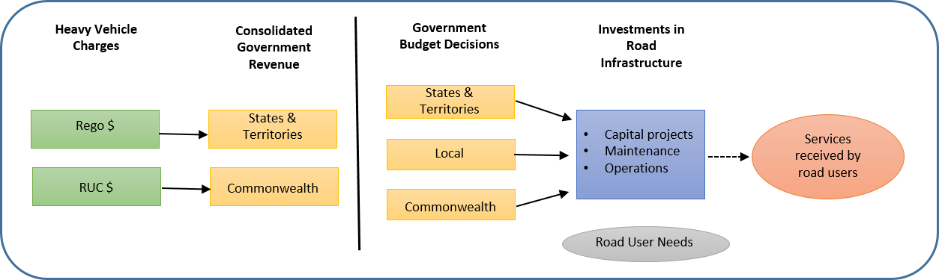
Disadvantages of the current system:
- Charges (revenue) don't reflect each individual user's share of road costs.
- No incentive for treasuries or road owners to prioritise road spending to benefit heavy vehicle operators either now or in the future.
- Charges set do not take into account the future network needs and this increases road asset lifecycle costs.
- Volatility in heavy vehicle charges and revenue results from the current charges methodology.
- Charges are not automatically or consistently applied across Australia.
Doing nothing to reform heavy vehicle investment and charging arrangements will mean that, increasingly, roads managers will not be able to deliver the quality of road services necessary to meet the growing national freight task. The costs will be borne by the road transport industry in lost productivity; the community in higher costs of goods and services; and the economy in overall lower efficiency and productivity.

The response: Heavy Vehicle Road Reform
All levels of government in Australia are working together to establish a regulated market for the provision of road services to the heavy vehicle industry. The ultimate aim of this reform is an improved customer focus for heavy vehicle road users, linking their needs with the level of service they receive, the charges they pay and the investment of those charges back into road services where feasible.
The economic benefits of this reform are estimated to range from $6.5 to $13.3 billion over the next 20 years. Key benefits would include:
- Improved heavy vehicle productivity through better access, improved road maintenance and minimised freight costs for consumers.
- Economic growth, noting every 1 percent increase in heavy vehicle productivity leads to a $1 billion increase in Australia’s GDP.
- Safeguarding Australia’s $470 billion road network, through optimised asset management and efficient investments.
“Heavy Vehicle Road Reform” is a significant, multi-year national reform comprising a range of elements, being progressed according to a road map endorsed by the Council of Australian Governments and its Transport and Infrastructure Council. Each step of the reform, including any new arrangements for road user charging, will only go ahead if governments are satisfied that benefits to the community would outweigh the costs.

Principles of Heavy Vehicle Road Reform
The ultimate aim of Heavy Vehicle Road Reform is to produce a more accountable, transparent, fair and efficient system for funding Australia’s roads and charging heavy vehicle operators for their road use.
Accountable | Funding and investment decisions accountable to heavy vehicle road users
Transparent | Heavy vehicle road users can see how their charges are set and spent
Fair | Heavy vehicle road users pay in proportion to their use of road assets
Efficient | Funding is directed to investments that deliver the greatest benefit in the most efficient way. Asset use is optimised.

Elements needed to realise Heavy Vehicle Road Reform
There are five key elements needed to realise the full benefits of Heavy Vehicle Road Reform:
User-focused level of service framework, to set required service provision for all roads (including less travelled) | Road authorities are authorised and accountable for investments to deliver those service levels | Independent oversight ensures fair and efficient price setting to recover that investment | Funding arrangements in place to ensure revenues are delivered to road authorities
- Governments define level of service (such as heavy vehicle access) requirements in a way that drives the right amount of road investment.  - Users have input into those service standards, to ensure standards match their preferred trade-off between service and cost. | - Capital expenditure and maintenance activities are targeted to high benefit areas.  - Road authorities are accountable to heavy vehicle road users and end-users.  - Heavy vehicle operators and industry have input into investment decisions, providing better signals to road managers about what they should invest in. | - Charges are set to reflect the efficient cost of managing roads over the life of road assets, independent of budgetary and political considerations.  - Independent oversight of investments and service levels will provide heavy vehicle operators with a predictable path for charges, improving decision making and delivering economic and safety benefits. | - Heavy vehicle operators can see how charges are reinvested in infrastructure.  - Road managers can see where revenue is coming from and respond to customer preferences.  - Funding provisions are in place for less-travelled roads and community service obligations are delivered against level of service requirements.
Access to better data about roads and road expenditure
- Good road-related data will underpin all elements, and lead to better-informed regulatory, pricing, funding and investment decision-making.
- In time, access to better data through new technologies will enable the independent overseer to set more cost-reflective road charges, and more accurately assess investment needs and funding requirements.
- What could a new system look like?
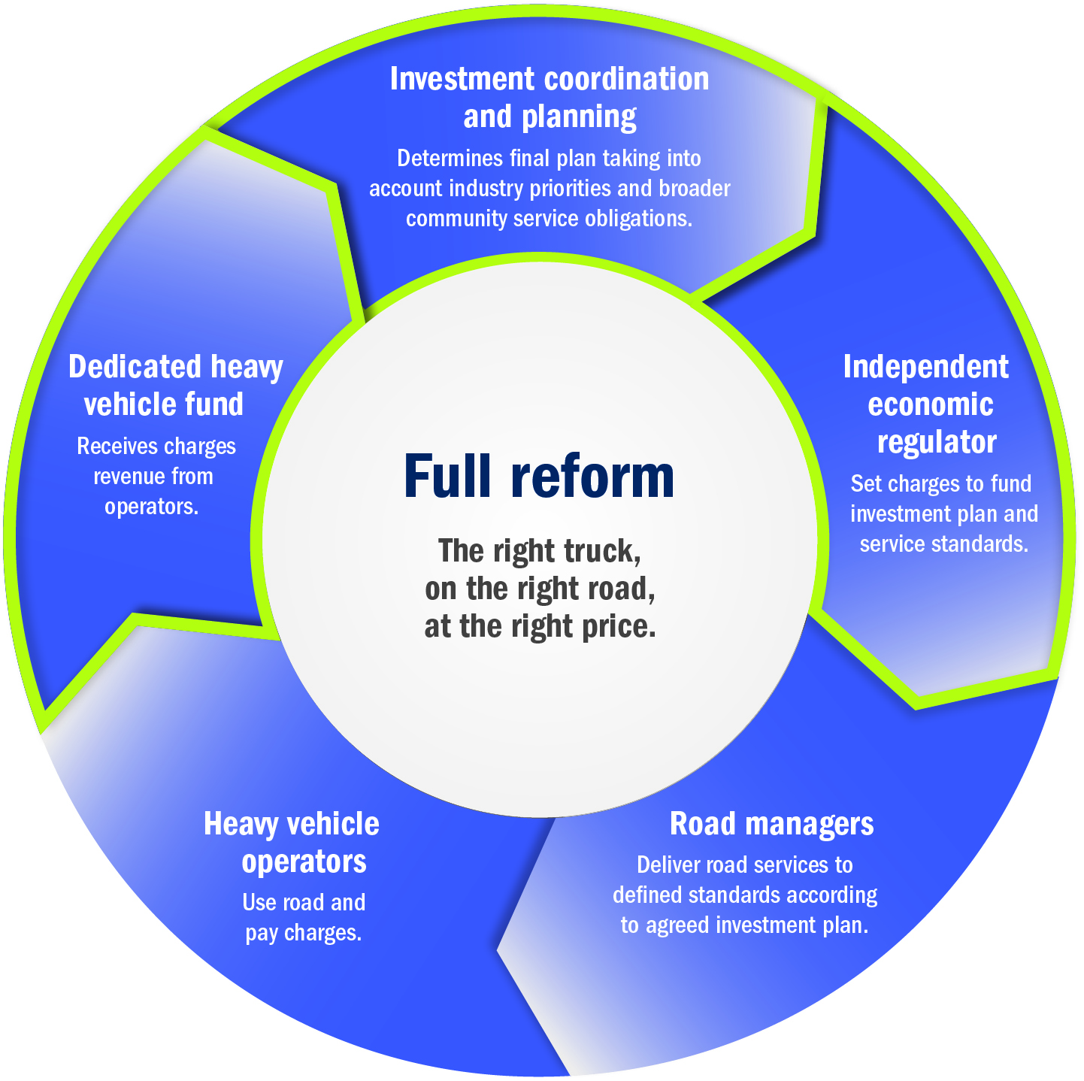

Advantages of a new system:
- Charges will reflect each user’s share of road costs.
- Road owners have a direct incentive to invest in meeting heavy vehicle users' needs.
- Usage data will support better planning and investment decision making.
- Secure funding will help maximise efficient lifecycle management of road assets, reducing costs.
- Independent economic regulation will ensure the 'right truck on the right road at the right time'.
- Allows for transparent government funding on community service obligations.
As a longer-term priority, it will also be important to consider the way the provision of road services to Australians driving light vehicles (97 per cent of vehicles in the national fleet) is funded. However, that is not the subject of the current reform process involving heavy vehicles.
- Heavy Vehicle Road Reform: Road map and progress to date
Shifting to a system where heavy vehicle infrastructure is provided as an economic service is complex and will take time to implement. The reform requires substantial change by governments and industry to policy, financial, institutional and governance arrangements. In addition, heavy vehicle users, and the industry more broadly, will need to understand and participate in new investment decision making and charge setting processes.
In May 2015, the Transport and Infrastructure Council endorsed a phased road map for Heavy Vehicle Road Reform. In December 2015, the Council of Australian Governments directed transport ministers to accelerate Heavy Vehicle Road Reform.

The Heavy Vehicle Road Reform road map
The road map for Heavy Vehicle Road Reform outlines an incremental and pragmatic approach to progressing reform of heavy vehicle investment and charging arrangements.
Each phase of the reform road map aims to progressively strengthen the links between the supply of, and demand for, heavy vehicle road services. In line with economic analysis and feedback from industry, the road map prioritises supply side measures in progressing reform with charging reforms only considered later. Each phase offers benefits to industry and government with costs – to industry in particular – minimised until later in the reform process when they are expected to start reaping the benefits of earlier phases of reform.
Progression beyond each phase of reform will be subject to the specific agreement of governments.

Summary of the 4-phase road map for progressing Heavy Vehicle Road Reform
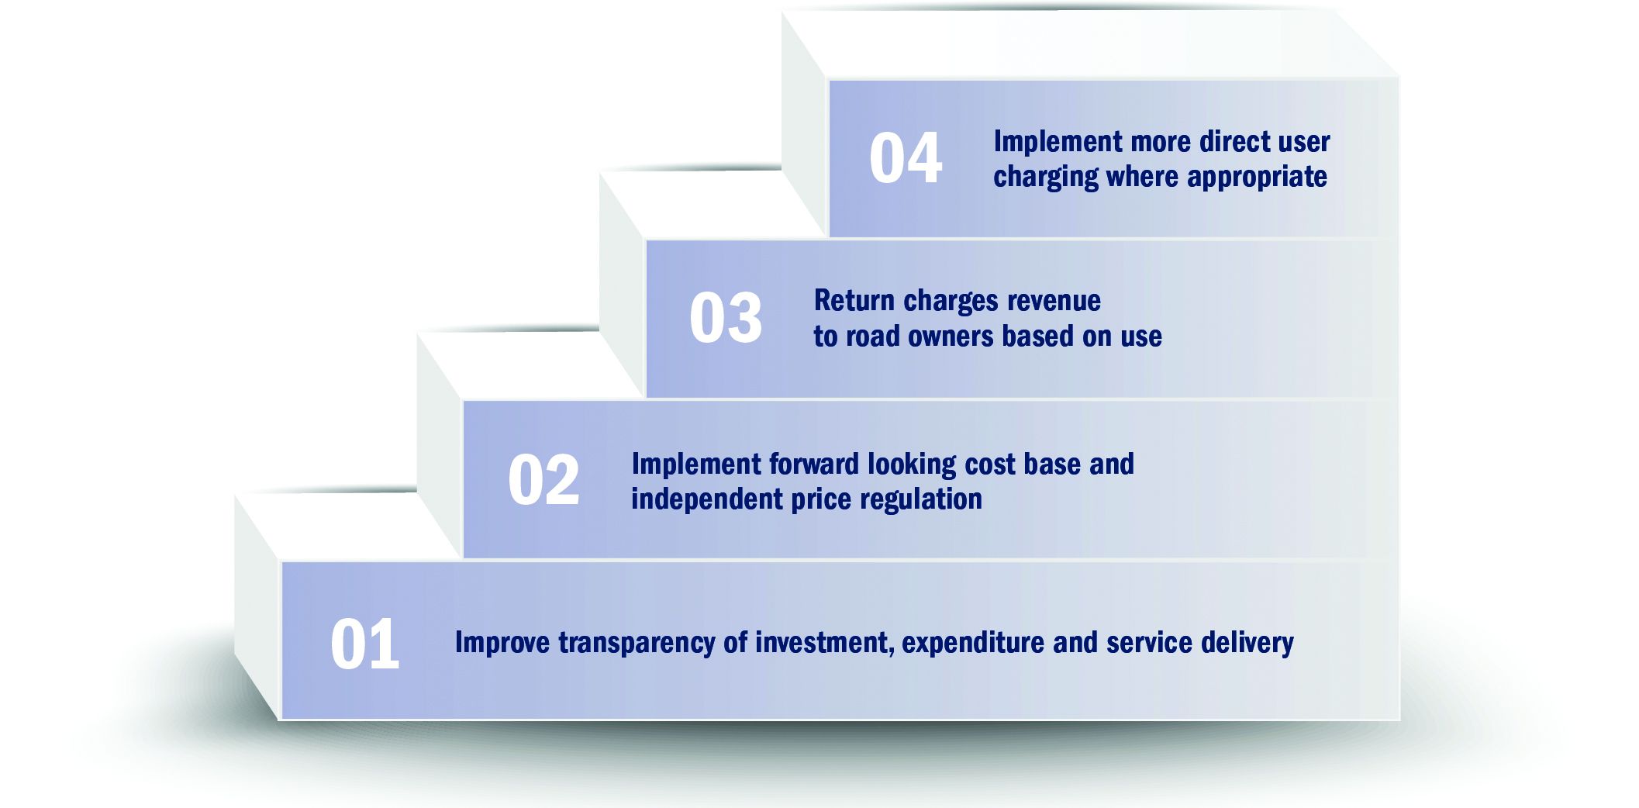

Progress on reform to date
The Commonwealth and state and territory governments have been progressing Heavy Vehicle Road Reform under this road map. The first phase of reform aimed to improve transparency around road expenditure, investment and service delivery. Initial measures have included the publication of the heavy vehicle asset registers and state and territory expenditure plans, with the second editions published in early 2017. These provide a basic level of reporting of service levels and proposed expenditure on our key freight routes.
The second phase of reform aims to implement two important governance measures – a forward-looking cost base and independent price regulation for heavy vehicles. In November 2017, the Transport and Infrastructure Council agreed to commence work on a regulation impact statement to assess options for independent price regulation. In addition, the Commonwealth Government has announced two initiatives to engage heavy vehicle operators on the reform: the National Heavy Vehicle Charging Pilot and the Business Case Program for Location-Specific Heavy Vehicle Charging Trials.
The third phase of reform (currently under development) would reform road funding arrangements to achieve a more direct link between heavy vehicle charges and road service delivery. The fourth phase would see PAYGO replaced with more direct road user charges.
Significant progress in other areas has also been made:
- Research into community understanding and awareness of current road funding arrangements for the full road market.
- Analysis of full market road revenue and expenditure trends out to 2050.
- Analysis of lessons to be learned from other countries (including trials of distance-based charging) and the regulation of other utility sectors.
- The National Transport Commission has developed a prototype model of how a forward-looking cost base could be applied to roads.
- Austroads reports into recommended models for community service obligations, service levels and funding regional and remote roads.

Independent price regulation and a forward-looking cost base
Phase 2 governance measures – independent price regulation of heavy vehicle charges and a forward-looking cost base – will provide the basis for a charging system which is more efficient, financially sustainable and fair. Independent price regulation of heavy vehicle charges will enable a regulator to determine charges at arm’s length from governments. A forward-looking cost base would enable governments to charge heavy vehicle road users on the basis of a fair return on an expenditure base that includes the forecast cost of building, maintaining and upgrading road infrastructure to at least a minimum standard.
A regulation impact statement, to assess the costs and benefits of implementing these governance measures – is being prepared. In July 2018 we anticipate public consultation on the RIS, which will include at least one face-to-face industry workshop.

National Heavy Vehicle Charging Pilot
The National Heavy Vehicle Charging Pilot (National Pilot) is a staged approach to trialling the replacement of the fuel-based Road User Charge and registration fees, with direct charges based on distance, mass and potentially location. It is a genuine opportunity for industry to test and shape what a new system might look like and how it could work for your business.
Through 2018, governments will work with industry peak bodies on the foundation work to design the National Pilot – including modelling different charge options, working through high and low tech options, defining data requirements and collecting baseline data to support evaluation. Interested operators are also welcome to participate in this foundation or design phase of the National Pilot if interested.
Towards the end of 2018, participants will be sought for the first on-road stage, which will see participants providing road use data and in turn receiving a ‘mock invoice’ outlining charges under different scenarios. This process will provide information on how different potential charging scenarios could work for your business. It is an opportunity to provide feedback on what works and what doesn’t to shape and narrow down potential options. The Department of Infrastructure, Regional Development and Cities intends to publish major reports and findings.
Following an evaluation, based on the findings of these first two stages and views of participants, governments will consider if and how to allow interested participants opt-in to ‘real money’ trials.
The first two stages of the National Pilot will run through to 2020 and provide an opportunity for industry to test and shape how a new system could work in practice.
People who are interested in the National Pilot can find out more at https://infrastructure.gov.au/roads/heavy/charging-trials/index.aspx.

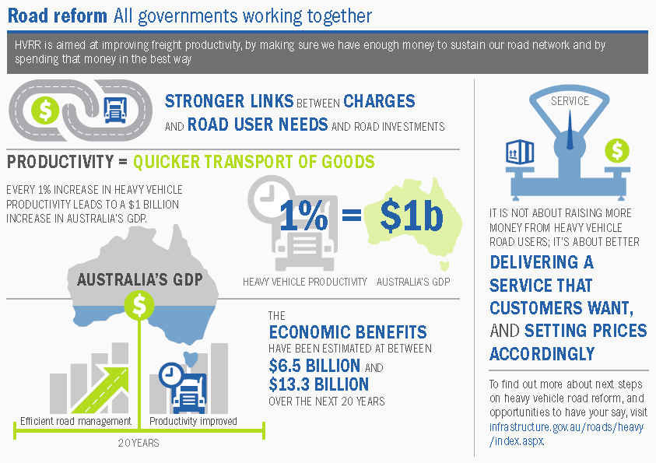

- Next steps
Governments are keen to continue working with heavy vehicle industry bodies, representatives and operators to better understand their needs and views on heavy vehicle road reform, to inform the assessment of implementation decisions to transition to a new system. In 2018, industry can get involved with two key processes:
- The public consultation on the regulation impact statement assessing the costs and benefits of independent price regulation.
- Design of the National Heavy Vehicle Charging Pilot.

[This page has been left intentionally blank]

Bureau of Infrastructure, Transport and Regional Economics (BITRE) (2017), Yearbook 2017: Australian Infrastructure Statistics, https://bitre.gov.au/publications/2017/yearbook_2017.aspx
ACIL Allen, The Economic Significance of the Australian Logistics Industry, report commissioned for the Australian Logistics Council, 2014.
S Alchin, Establishing a regulated asset base and applying a corporatised delivery model to the Australian road network – opportunities and challenges, ITF Discussion Paper, 2018.
Australian Bureau of Statistics, Motor Vehicle Census, Australia, 31 January 2017.

